ASAP Safety Plan

2025



Mission Statement

“Promoting health, self-awareness, self-esteem and the education of our youth by empowering them to succeed”.

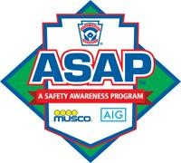

|  |  |
| --- | --- |
|  |  |
| spacer |

Table of Contents

Welcome Letter

West Salem Little League Board of Directors 2025

Emergency Contact Phone Numbers/Reporting Accidents

WSLL Code of Conduct

WSLL Safety Code of Conduct

Coach Clinic/Pre-Game Safety/FieldInspection

Safety and Injury Prevention

Volunteer Information

Concession Stand

Equipment/Machinery

Little League Parents Code of Conduct

Parents Role in Safety

Field Locations

COVID-19 Safety Procedures / Oregon School Athletic Association Guidance

Welcome 2025 Managers, Coaches and Parents!

The attached is West Salem Little League’s Safety Plan (ASAP) for the upcoming 2025 baseball and softball season. This plan was developed to ensure that the participants of West Salem Little League have the opportunity to play, learn, and have fun this year.

This annual report will be revised and updated each year for the safety of everyone involved with West Salem Little League. This plan discusses specific guidelines and criteria that ensure the safe operation of Little League Baseball and Softball at the West Salem Little League fields.

Reading and acknowledging this plan is critical and mandatory for all managers. This plan will also need to be shared with coaches, parents, umpires, concession stand operators and volunteer parents. The ASAP Safety   
Plan will be posted on our league website. This plan will help West Salem Little League maintain the highest possible level of safety and conduct from everyone involved.

Your feedback and suggestions are an important part of this effort. If anyone feels they can contribute by suggesting or recommending ways to improve the safety of WSLL, please feel free to contact me at President@wsll.net, by phone at (206) 992-0328, or any board member. We look forward to a safe and exciting 2025 Little League season!

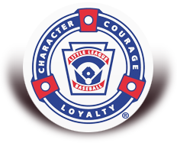

Be safe and have fun,

Ethan Griffith

President

West Salem Little League 2025

Board of Directors

**Board Position Name**

**President Ethan Griffith**

**Vice President / Safety Officer Ryan Steckly**

**Umpire in Chief Nate Wixom**

**Treasurer Kenny Newton**

**Softball Director Jessica Popinga**

**Scheduler Nick Reed and Mike Powers**

**Background/Security Ethan Griffith**

**Equipment Manager Nick Reed and Mike Powers**

**Player Agent Vacant**

**Sponsorships Vacant**

**Secretary Vacant**

**Snack Shack Vacant**

**Field Managers Nick Reed, Mike Powers, Cassidy Stanley**

**Members at Large Tim Lee, Jason Doneth, Andrea Doneth, Alex Yeaney,**

**Jay Bacus**

**Emergency Phone Numbers**

**All EMERGENCIES 911**

Salem Police Department 503-588-6123

Polk County Sheriff 503-623-9251

Falck Ambulance Service 503-588-6428

Salem Hospital 503-814-1572

Life Flight 503-678-4364

Poison Control 1-800-222-1222

Dog Control 503-623-9251

*An overview map has been provided to local Emergency Medical Services

that respond to the West Salem Little League Fields.

**Reporting Accidents**

All accidents and injuries shall be reported to the league safety officer **within 24 hours**. After notification the safety officer will notify the WSLL President in which all information will be recorded and the proper forms completed and mailed to the insurance representative. If the safety officer is unavailable, the WSLL President is to be notified of the accident or injury. If the WSLL President or Safety Officer cannot be located on the facility grounds, any board member can be notified of the accident or injury. Check at the concession stand to see, who the responsible board member at the fields is for that day.

**Concussions**

**West Salem Little League will follow Oregon Senate Bill 348 and Oregon Administrative Rule 581-022-0421 in regards to concussion policies and procedures.**

**The 2009 Legislature enacted Senate Bill 348 in an attempt to respond to the serious issue of sports-related concussion injuries that often result due to inappropriate treatment and diagnosis. This legislation requires the following:**

**1. Yearly training of all coaching staff who instruct or train members on a school athletic team**

**2. Prohibition of student athletes from participating in any athletic event or training until a medical release has been obtained for any athlete who exhibit signs, symptoms or behaviors consistent with a concussion; have received a blow to the head or body; or have been diagnosed with a concusion.**

**Concussion Management Training Oregon Administrative Rule, the Safety of School Sports-Concussion 581-022-0421, details the concussion management training requirements included in SB 348.**

**(3) The training required of coaches under this rule shall include the following:**

**(a) Training in how to recognize the signs and symptoms of a concussion; (b) Training in strategies to reduce the risk of concussions;**

**(c) Training in how to seek proper medical treatment for a person suspected of having a concussion; and**

**(d) Training in determination of when the athlete may safely return to the event or training.**

**Recommendations for Coaches**

**Coaches play a key role in helping to minimize the risks for concussions and responding to them properly when they occur. There are many steps coaches can take to ensure the best outcome for individual athletes and the team as a whole. These include:**

**1. Educate athletes and parents about concussions. Talk with athletes and their parents about the dangers and potential long-term consequences of concussion. Explain your concerns about concussion and your expectation of safe play to athletes, parents, and assistant coaches. Distribute concussion fact sheets to athletes and parents (fact sheets are also available in Spanish) at the beginning of the season and again if a concussion occurs.**

**2. Insist that safety comes first. a. Teach athletes safe playing techniques and encourage them to follow the rules of play. b. Encourage athletes to practice good sportsmanship at all times. c. Make sure athletes wear the right protective equipment for their activity. This equipment should fit properly, be well maintained, and worn consistently and correctly. d. Review the athlete fact sheet with your team to help them recognize the signs and symptoms of a concussion.**

**3. Prevent long-term problems. A repeat concussion that occurs before the brain recovers from an initial injury—usually within a short period of time (hours, days, weeks) — can slow recovery or increase the likelihood of long-term problems. In rare cases, repeat concussions can result in brain swelling, permanent brain damage, and even death. Keep athletes with a known or suspected concussion from play until they have been evaluated and given permission to return to play by a health care professional with experience in evaluating concussions.**

**If you suspect that an athlete has a concussion, implement the four-step Heads Up action plan:**

**1. Remove the athlete from play immediately. Look for the signs and symptoms of a concussion if your athlete has experienced a bump or blow to the head or body. When in doubt, sit them out.**

**2. Ensure that the athlete is evaluated by a health care professional experienced in evaluating for concussion. Do not try to judge the severity of the injury yourself. Health care professionals have a number of methods they can use to assess the severity of concussion. As a coach, recording the following information can help health care professional in assessing the athlete after the injury: Cause of the injury and force of the hit or blow to the head or body. Any loss of consciousness (passed out/knocked out) and if so, for how long. Any memory loss immediately following the injury Any seizures immediately following the injury. Number of previous concussion (if any, if known).**

**3. The coach is responsible for notifying the athlete’s parents or guardians about the possible concussion and give them the fact sheet on concussion. Make sure they know that the athlete should be seen by a health care professional experienced in evaluating for concussion.**

**4. Keep the athlete out of play the day of the injury and until a health care professional, experienced in evaluating for concussion, says s/he is symptom-free and it’s ok to return to play. A repeat concussion that occurs before the brain recovers from the first – usually within a short period of time (hours, days, weeks) – can slow recovery or increase the likelihood of having long-term problems. In rare cases, repeat concussions can result in edema (brain swelling), permanent brain damage, and even death.**

**Safe Sport Act of 2017**

**The “Protecting Young Victims from Sexual Abuse and Safe Sport Act of 2017” mandates that all amateur sports organizations, which participate in an interstate or international amateur athletic competition and whose membership includes any adult who is in regular contact with an amateur athlete who is a minor must report suspected child abuse, including sexual abuse, within 24 hours to law enforcement.**

**An individual who is required, but fails, to report suspected child sexual abuse is subject to criminal penalties. If an individual suspects a case of abuse within their league, they should report it to the appropriate child services organization and/or local law enforcement as well as, their League President and District Administrator**

**Any individual involved with West Salem Little League who is an approved volunteer MUST complete the Safe Sport Training Program Online. This is not an option, any volunteer who fails to successfully complete the Safe Sport Training will NOT be allowed to participate in any West Salem Little League function, this includes games, practices, tryouts, meetings etc…**

**Please visit the following link to take your Safe Sport Abuse Awareness training** [**Safe Sport Training**](https://www.littleleague.org/player-safety/child-protection-program/safesport-resources-parents/)**. Scroll to the bottom and click on the “ Take The Free Online Course” under the Abuse Awareness for Adults section.**

**Once you have completed the training, please email a copy of the certificate to** [**President@wsll.net**](mailto:President@wsll.net)

**West Salem Little League Code of Conduct**

The 2025 West Salem Little League Board of Directors recommends the following code of conduct. This code of conduct should be followed at all times.

No board member, manager, coach, player, official or spectator shall:

Touch, push, shove, strike, or otherwise threaten (physically or verbally) any other individual.

Exhibit unsportsmanlike conduct including throwing of gloves, helmets, hats, bats, balls, or any other object.

Use or cause the use of unnecessarily rough tactics in the play of a game.

Use profane, obscene or vulgar language.

Exhibit physical contact of an inappropriate nature.

Use tobacco within the WSLL field areas.

Speak disrespectfully to any other manager, coach, player, official, spectator or board member.

Any other behavior or conduct that could be interpreted by any member of WSLL or its guests as disrespectful.

Any unsportsmanlike behavior occuring on/off the field or through social media will be subject to disciplinary action by the board of directors.

This conduct shall be maintained on any field or in any facility in which the team represents West Salem Little League including All-Star and championship play.

Contact us:

President@wsll.net

West Salem Little League

PO Box 5445

Salem, OR  97304

**West Salem Little League Safety Code of Conduct**

In 1995, ASAP (A Safety Awareness Program) was introduced with the goal of re-emphasizing the position of Safety Officer “to create awareness, through education and information, of the opportunities to provide a safer environment for kids and all participants of Little League Baseball and Softball”. This manual is offered as a tool to place some important information at a manager’s and coaches’ finger tips.

**DO:**

* Reassure and aid children who are injured, frightened or lost.
* Provide, or assist in obtaining, medical attention.
* Know your limitations.
* Carry your first aid kit to all games and practices.
* Assist those who require medical attention.
* **Look** for signs of injury (blood, black and blue, deformity, etc).
* **Listen** to what the injured person is saying.
* **Feel** gently and carefully the injured area for signs of swelling or broken bone.
* Have your player’s Medical Clearance Forms with you at all times.
* Make arrangements to have access to a phone.

**Don’t:**

* Administer any medications.
* Hesitate in giving aid when needed.
* Be afraid to ask for help if you’re not sure of proper procedures.
* Leave an unattended child at a practice or game.
* Hesitate to report issues to the league’s Safety Officer.

**Coaches Meeting and Clinic**

Attendance at the March, 2025 Coaches Meeting and Clinic is MANDATORY for all managers and coaches. No exceptions. This session will include:

* Abuse Training / Concussion / Diamond Leader Overview and Requirements
* Gear Handout
* Coach Clinic

Coaches will be taught the fundamentals of hitting, sliding, catching, fielding and pitching. Coaches will also learn the basics of first aid and how/when to contact emergency medical services.

**Pre-Game Safety/Field Inspection**

All managers, and/or coaches and/or umpires are required to walk the entire field to identify any safety hazards and ensure that the field is safe prior to use for games or practices. Any hazards should be eliminated prior to the start of play and reported to the safety officer and/or a board member within 24 hours.



**Safety and Injury Prevention**

* First Aid Kits are in all Gear Bags provided to each Team/Head Coach.
* Extra first aid kits and supplies are at the concession stand.
* No games or practices should be held when weather or field conditions are unsafe.
* Grounds should be inspected frequently for holes, damage, stones, glass and other foreign objects. Any problems should be reported to a board member.
* All team equipment should be stored in the team dugout and not within the “field of play”.
* During practice and games, all players should be alert and watching the batter on each pitch.
* Batters must wear Little League approved protective helmets during batting practice and games.
* Catcher must wear catcher’s helmet, mask, throat guard, long model chest protector, shin guards and protective cup with athletic supporter at all times (males) for all practices and games.
* During sliding practice, bases should not be strapped down or anchored.
* Players may not wear watches, rings, pins or metallic items during games or practices.
* The catcher must wear catcher’s helmet and mask with a throat guard while warming up pitchers.
* No playing in the parking lots.
* No playing on and around lawn equipment.
* Always be alert for traffic when crossing roadways.
* No swinging bats or throwing baseballs/softballs within the walkways and spectator areas.
* No throwing rocks or climbing on fences and dugouts.
* Observe all posted signs. Players and spectators should be alert at all times for foul balls and errant throws.
* During games the players must remain in the dugout area in an orderly fashion at all times.
* After each game, each team must clean up the trash in the dugouts and around the stands.

**Volunteers**

We know the greatest treasure we have is a child. As adults, we must ensure that these young people are able to grow up happy, healthy and above all, safe. Whether they are our children, or the children of others, each of us has a responsibility to protect them. They are our future and an endless source of joy.

Background checks are required of all volunteers. Recent advances in computer technology allowing increased access to public records, make it possible for these background checks (to see if an individual is a registered sex offender in a given state) to be conducted in every U.S. state.

Background checks are conducted on Mangers, Coaches, Board of Directors and any other persons, volunteers or hired workers, who provide regular service to the league and/or have repetitive access to, or contact with, players or teams. Covid-19 Vaccine Proof will need to be shown and/or approved exemptions prior to volunteering.

Failure to complete and submit the Volunteer Application Form by those required to do so will result in being barred from involvement of West Salem Little League.

**Concession Stand Safety**

* No minor under the age of 14 should be behind the counter without an adult.
* Food covered at all times to prevent insects from resting on the food.
* Inspect cooking equipment before use and report damage to the Head of Concessions or Board Member.
* Counters and equipment used should be wiped down at the end of the day.
* Cleaning chemicals must be stored in a separate cabinet.
* Certified fire extinguisher suitable for grease fires must be placed in plain sight at all times.
* Only healthy workers should prepare food. Anyone feeling ill or sick should not be allowed in concession stand area.
* All concession stand workers should be instructed in the proper use of fire extinguishers.
* All concession stand workers are to be aware of the location of the first aid kit located in the concession stand.
* Utensils washed and put away at the end of the days games.
* Concession stand workers must wash hands each time they use the rest room and after handling foreign objects.

**Food Handler Certification/Permit**

West Salem Little League will require all concession volunteers who open or close the concession stand to obtain a Food Handler Certification. This course must be recognized and approved by the Oregon Health Authority. The cost to obtain a Food Handler Permit is $10.00.

This card is valid for a 3 year period. West Salem Little League will reimburse the cost to volunteers for the permit. This will ensure we as a league are following the best practices when handling food for everyones safety. If you currently have a Food Manager Training Certificate this will be accepted in lieu of a Food Handler Card. As a reminder, if you have a Food Handler Permit issued from another state it is not recognized here in Oregon and you would need to take an approved course for Oregon.

**Equipment / Facility**

* The WSLL President shall issue keys to the equipment / facility.
* All keys shall be returned at the end of the season, NO EXCEPTIONS.
* Equipment facility shall remain locked at all times.
* All chemicals located in the equipment facility shall be labeled and stored in its original container, if available. MSDS Sheets will be available.
* Any loose chemicals within the equipment facility shall be cleaned and disposed of to prevent accidental poisoning.
* Dispose of outdated products as recommended by the manufacturer.
* Use chemicals only in well ventilated areas.
* Wear proper protective clothing when handling toxic substances.

**Equipment**

The equipment manager shall inspect all equipment before the start of the first practice or game. Once the equipment is distributed by the league it becomes the responsibility of the managers or coaches. They should inspect the equipment before each game or practice. If damaged, the equipment should be taken out of service and the equipment manager notified. Damaged equipment is to be either fixed or destroyed to prevent future use. Many kids bring their own equipment, the manager or coach should make sure that the equipment meets and complies with Little League Regulations.

**Machinery**

Tractors, mowers and other heavy machinery will:

* Be operated by approved volunteers.
* Not to be operated by person under the age of 14.
* Never operated in a careless or reckless manner.
* If something breaks or needs repair, please notify any board member.

**Little League Parents Code of Conduct**

West Salem Little League has implemented the following Parent Code of Conduct for the important message it holds about the proper role of parents in supporting their child in sports. Parents should read, understand, and sign this code of conduct prior to their children participating in our league. Any parent guilty of improper conduct at any game or practice will be asked to leave the sports facility and be suspended from the following game. Repeat violations may cause a multiple game suspension, or the season forfeiture of the privilege of attending all games.

**Preamble**

The essential elements of character building and ethics in sports are embodied in the concept of sportsmanship and six core principles: trustworthiness, respect, responsibility, fairness, caring, and good citizenship. The highest potential of sports is achieved when competition reflects these "six pillars of character."

I therefore agree:

1.    I will not force my child to participate in sports.

2.    I will remember that children participate to have fun and that the game is for youth, not adults.

3.    I will inform the coach of any physical disability or ailment that may affect the safety of my child or the safety of others.

4.    I will learn the rules of the game and the policies of the league.

5.    I (and my guests) will be a positive role model for my child and encourage sportsmanship by showing respect and courtesy, and by demonstrating positive support for all players, coaches, officials and spectators at every game, practice or other sporting event.

6.    I (and my guests) will not engage in any kind of unsportsmanlike conduct with any official, coach, player, or parent such as booing and taunting; refusing to shake hands; or using profane language or gestures.

7.    I will not encourage any behaviors or practices that would endanger the health and wellbeing of the athletes.

8.    I will teach my child to play by the rules and to resolve conflicts without resorting to hostility or violence.

9.    I will demand that my child treat other players, coaches, officials and spectators with respect regardless of race, creed, color, sex or ability.

10.  I will teach my child that doing one's best is more important than winning, so that my child will never feel defeated by the outcome of a game or his/her performance.

11.  I will praise my child for competing fairly and trying hard, and make my child feel like a winner every time.

12.  I will never ridicule or yell at my child or other participant for making a mistake or losing a competition.

13.  I will emphasize skill development and practices and how they benefit my child over winning. I will also deemphasize games and competition in the lower age groups.

14.  I will promote the emotional and physical well-being of the athletes ahead of any personal desire I may have for my child to win.

15.  I will respect the officials and their authority during games and will never question, discuss, or confront coaches at the game field, and will take time to speak with coaches at an agreed upon time and place.

16.  I will demand a sports environment for my child that is free from drugs, tobacco, and alcohol and I will refrain from their use at all sports events.

17.  I will refrain from coaching my child or other players during games and practices, unless I am one of the official coaches of the team.

18.  I will not use social media sites to discuss negative opinions about players, coaches, managers, volunteers, and/or board members.

I also agree that if I fail to abide by the aforementioned rules and guidelines, I will be subject to disciplinary action that could include, but is not limited to the following and not neccesarily in this order:

•     Verbal warning by league official, manager/coach, and/or board member of league.

•     Written warning

•     Parental game suspension with written documentation of incident kept on file by league involved

•     Parental season suspension



Parents’ Role in Safety

Most of the existing Little League rules have a basis in safety. It is important to follow Little League rules for the safety of everyone involved. The managers and coaches are/or will be trained in first and safety. Please take the time to listen to the manager and coaches, learn these rules and make them common practice any time you practice baseball or softball with your children. Here are a few examples of our League’s rules.

**Complete a Medical Release** This enables emergency medical care if parent or guardian is not in attendance, and also informs managers, coaches and medical providers of allergies or other medical problems. This can be found on our website under the FORMS tab.

**No one holds a bat!** Many players bring their own bats to practice and games. Players should keep their bats in their bags, in the dugout or on the ground in front of them until they are needed. **No one holds a bat except when going to the plate.**

**The manager or coach will never leave a player alone at the field** It is very important that parents are on time to pick up the children on time. It is recommended that parents remain at the field if possible. If this is not possible, please contact the coach or manager prior to the event

**No alcohol or tobacco on the field** If volunteers must smoke or chew tobacco, please do it away from the players in designated areas. If the players can see you smoke or chew, you are too close!

**Please be extra cautious when entering and leaving the parking lots** Children may not always look for you, especially young future ball players.

**It is important that you share any medical information that may affect your child during games and practice** If you have concerns or questions about this please contact the manager or League Safety Officer. All information is considered confidential.

**Have your child eat a snack before practice or games** Hungry ball players don’t concentrate well.

**Routinely check your child’s equipment for safety concerns.**

**Arrive early** Get to practice and games early to allow for proper warm ups

**Only Authorized Personnel in the dugouts** – Photographers do not count!



**PLEASE REMEMBER**

**THESE ARE KIDS**

**THIS IS A GAME**

**THE COACHES VOLUNTEER**

**THE UMPIRES ARE HUMAN**

**THIS IS NOT PROFESSIONAL BASEBALL**

West Salem Little League Field Locations

West Salem High School

1776 Titan DR NW

Salem, Oregon 97304

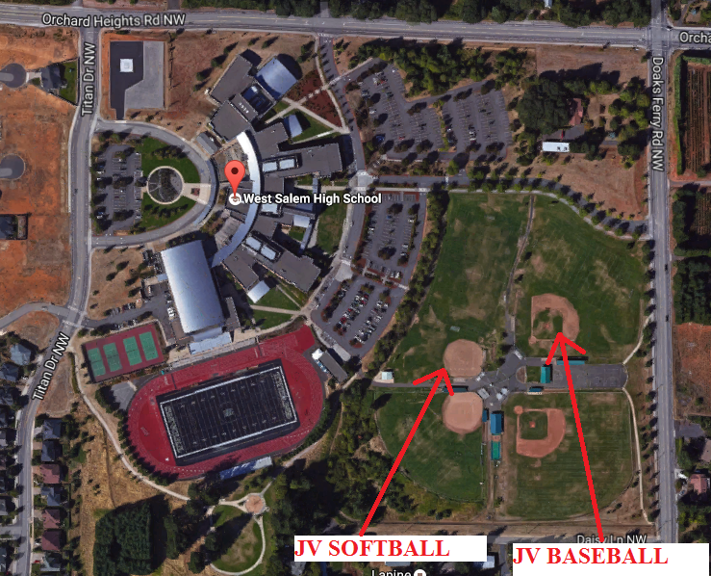

Walker Middle School

1075 8th ST NW

Salem, OR 97304

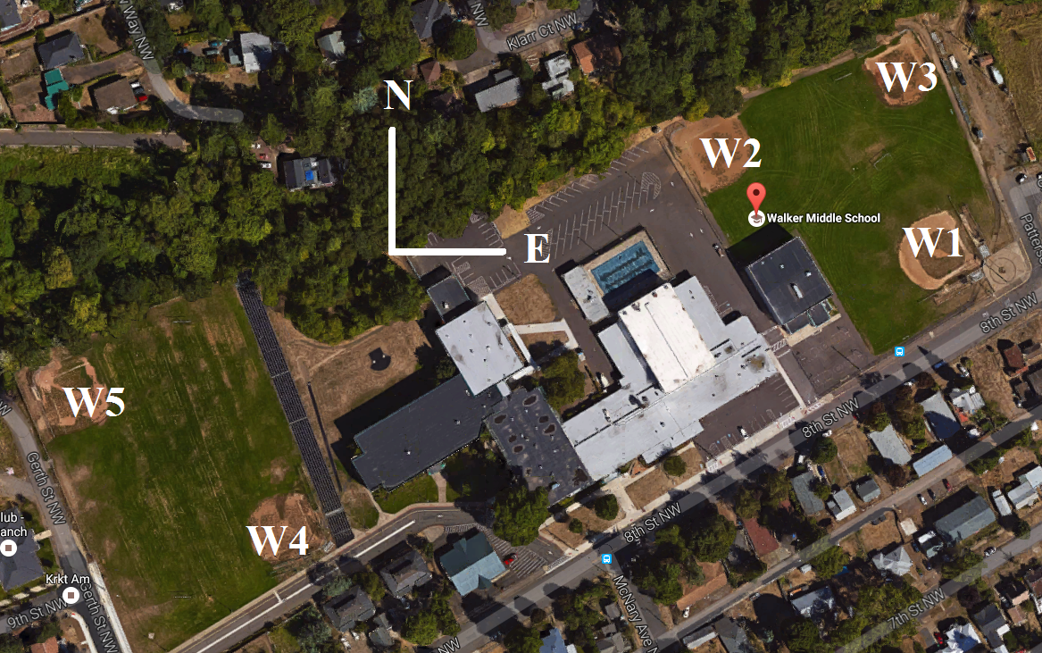

W2

W3

**Walker Field W1**  
Corner of Patterson & 8th (Majors Baseball)

**Walker Field W2  Walker Field W3**  
NE Corner By old Pool  
  
  
**Walker Field W4  Walker Field W5**  
SE Corner of Football Field  NW Corner of FB Field